**Wealthsimple**

**Overview and Origins**

Wealthsimple is a company that was incorporated in 2014 by Michael Katchen, who at the time was only 27 years old. The idea to create Wealthsimple came about while Katchen was working at McKinsey, a global consulting firm. Katchen had been interested in investing since he was very young and had even developed spreadsheets with advice on how to build successful portfolios, which he distributed amongst his friends[1]. These spreadsheets and their easy access to information would soon develop and evolve into what is known today as Wealthsimple.

In 2014 it took Katchen only two and a half weeks to raise the 2 million dollars required for the start-up. One of its big investors was Christian Lassonde. Lassonde owns Toronto venture capital fund ‘Impression Ventures’, which contributed $500,000 to the start-up. The rest of the initial funding came from a series of other investors and techangels. In the 3 years following its inception the company received major funding of over $100 million from Power Financial Corp, to facilitate its expansion into the United States and in 2019, Wealthsimple had raised another $100 million backed mostly by German investment firm Allianz X[2].

**Business Activities**

Katchen claims Wealthsimple’s main objective is to “democratize access to really high end sophisticated advice – at a low cost”. So the company focused on creating an investment management service that allowed clients to get advice and make sounds financial decisions without being reliant on big Canadian banks, which charge incredibly high fees. According to The Financial Post, Canada is among the countries with the highest investment fees globally. This is where Wealthsimple saw an opportunity for its robo-advisors to enter the market. Robo advisors are intended to make investing less scary and complex for first time investors, while also saving them money. Clients with the most basic accounts are charged .05% fee on their account value, plus a .02% service fee on ETF’s[3].

Currently, 80% of Wealthsimple’s clients are under the age of 45 and nearly 50% of them are first time investors1. The company also caters to a younger demographic by offering options such as ‘socially responsible investing portfolios’ and a ‘Halal investment portfolio’, so that there are inclusive options for everyone. A lot of these first time investors don’t have the capital to hire financial planners so Wealthsimple offers a good alternative money management strategy.

In terms of competitive advantages Wealthsimple has a few. First off, their fees are significantly lower than traditional banks which is a huge selling point to investors. Wealthsimple also has no minimum balance requirement, which allows the company to target people who are young and may be just starting out in their careers. There is also the option for a free portfolio analysis where an advisor will review financial statements and help put a plan in place for potential clients. Beyond this, the company also provides features such as tax loss harvesting, access to financial planners regardless of account balance, investments in fractional shares, and smart save accounts with a 1.66% interest rate[4].

When it comes to technological innovations Wealthsimple started off very basic. At its inception the company just used a Google docs spreadsheet. As the company started to grow, they developed a script and a web interface. An order generator was then created using a multi threaded Java microservice that pushed all the orders through to a brokerage. This microservice was good in the short term for pushing single orders through, but in the long run they needed something more powerful to handle the larger orders.

To mitigate these problems the company began prototyping a workflow engine using JSON. This workflow engine used Ruby code to determine when the next step was to be executed. The workflow also produced activity records, which kept a historical record of the data that was processed. The order calculator had the potential to be run on any service but the Wealthsimple team chose Python which allowed it’s analysts to use NumPy and SciPy[5]

**Landscape**

Wealthsimple is considered to be within the Fintech domain of wealth management as well as robo advising. Its Canadian competitors include Nestwealth, Just Wealth, Questwealth Portfolios and BMO Smartfolio among others. These companies did not exist 10 years ago and growth in these industries have required advancement and innovation in a variety of related fields.

One of these areas is cyber security. Identity verification and document security is of crucial importance because so much sensitive information is exchanged. A simple breach in security could cause personal information such as financial records and SINs to become public information. This has resulted in a need for constant innovation, growth and development in web security, so companies can make sure their clients feel that their information is protected and safe.

Another trend change is an increase in personalization. With the increase in personal modelling abilities, robo advisors can begin planning for major life events way in advance. The data allows for goals to be set and when things go off course the robo advisors can immediately rebalance things in order to mitigate loss and keep things on track. The customer’s journey can be tracked more closely today using demographic and psychographic data, than it would have been able to even ten years ago.

Finally advances in automation have allowed online investment portfolios to be monitored 24/7 from any remote location worldwide. The limitations brought on by office hours and time zones years ago, have now become almost obsolete. Portfolios can be rebalanced automatically, and equities can be bought and sold in real time from the comfort of the client’s own home at their convenience[6].

**Results**

So far the business impact of Wealthsimple has been impressive. In terms of metrics, as of March 31 2020, it is one of the country’s largest and fastest growing digital investment services. The small Toronto start-up has managed to expanded into the United States and the UK which is no small feat. With over 350,000 clients and climbing the most recent data claims to have over 6.8 billion in assets under its administration[7]

It is difficult to compare robo advisors because they each have different strengths and weaknesses. Barron’s magazine, which is an American weekly magazine that provides US financial stories and news, ranked the top 40 robo advisors in America and placed Wealthsimple was among its top ten. This is an impressive feat considering it is competing with US giants such as Vanguard Personal Advisor Services, which already has $172 billion under assets[8]. The following chart shows how each robo advisor compares in different areas.

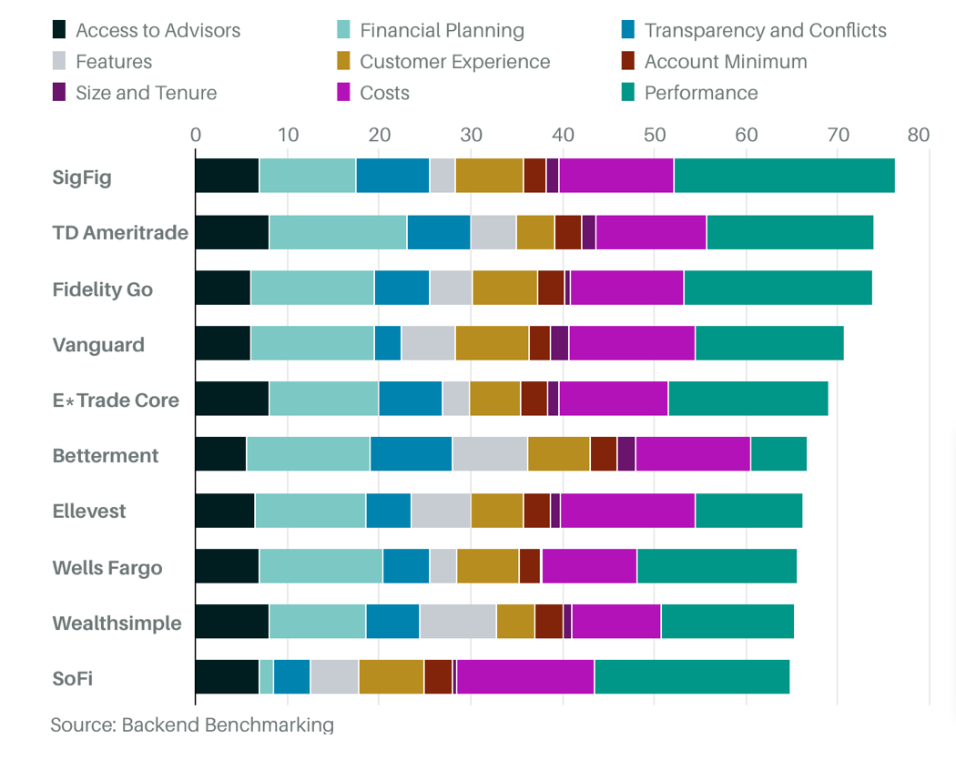

Although Wealthsimple ranks 9th in terms of Barron’s criteria, it’s still the only Canadian robo advisor to make the top ten.

It is also impressive to note that Wealthsimple ranked first in terms of its year to date returns. Despite none of the robo advisor’s having strong performances due to Covid 19, thanks to its fixed securities, Wealthsimple is the only company within the top ten to report a positive return.

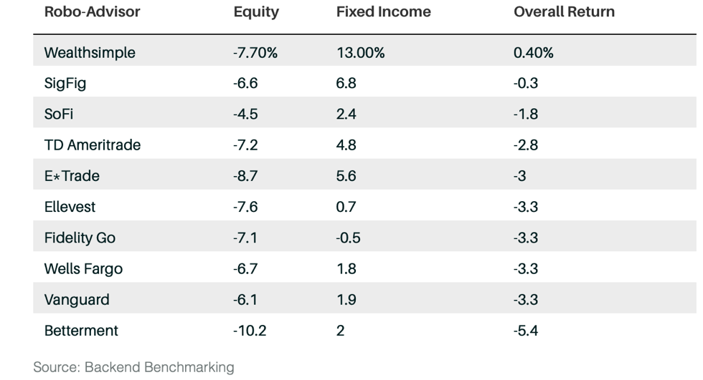

**Recommendations**

In terms of recommendations I think one thing that Wealthsimple could do would be to offer online webinars to first time investors. These webinars could explain in detail some of the key concepts of wealth management. First time investors and many people who are new to the country do not fully understand how equities and fixed income securities operate, let alone ETF’s and portfolios. I think educating people with these kinds of seminars could help them develop a deeper understanding of where they are putting their money and what it is doing. This in turn will likely make people less afraid of investing and more likely to trust Wealthsimple with their finances.

These webinars could then walk people through the steps of transferring over their money and setting up accounts in real time that way, people who aren’t up to date with technology wouldn’t feel overwhelmed and there is direct support available to them. This could be done via an online platform such as Zoom so that everyone would be able to interact with each other. There could even be a live chat option available through the app so that potential investors could have their questions answered in real time. If they are forced to wait for an email response, they could lose interest and decide that investing is too complicated and give up all together.

These technologies are appropriate because as time progresses the financial system is becoming more and more digitized. There are even people who are a bit older who are scared of technology and the rate it is growing. If you offer these people gradual step by step instructions and make them feel less overwhelmed they are more inclined to trust you going forward and the company can increase their client base.

**Conclusion**

I believe that Wealthsimple is a company that will continue to perform strongly. Its up to date with the most recent technological innovations and has a team of highly skilled individuals behind it. I hope that they continue to expand into other countries such as India, where I believe there is a lot of room for growth and many potential clients who could benefit from their services. I look forward to seeing where the company goes and what it does next within the realm of financial technology.

1. Casey, Q. (2015, April 10). Wealthsimple aims to turn financial service industry on its head with new low cost approach to investing. The Financial Post
2. Brown, R. (2019, May 22). Wealthsimple raises $75 million and says its close on path towards IPO. CNBC.
3. Wealthsimple (2018, April 17). Why Should I Pay Wealthsimple a .5% fee?. Wealthsimple.
4. O’Shea, A. (2020, Jan 15). Wealthsimple review 2020: Pros, Cons, and How It Compares. Nerdwallet
5. Kudlacz, M. (2017, June 20) Engineering At Wealthsimple: Reinventing Our Trading Platform for Scale. Medium.
6. BNP Wealth Management. (2018. Nov 11) Winds of Change: The Future of Fintech in the Wealth Management Industry
7. Power Corporation of Canada. Fintech Investments
8. Max, S. (2020, July 26) Robo Advisors Thrived Amid the Covid-19 Volatility. Here’s Barron’s Latest Robo Ranking. Barron’s.